Project 1

Manipulating Color Images

By: Nimrat Bedi

Nxb200004

**First Program: Linear Stretching**

File name: ls.py

Images used in the program are:

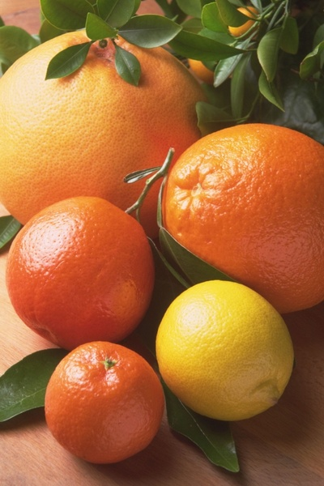

And

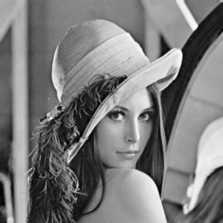

The image which is enhanced by using Linear Scaling is:

Here the image colors are better from the original image as we have stretched the values of Luv to its fullest.

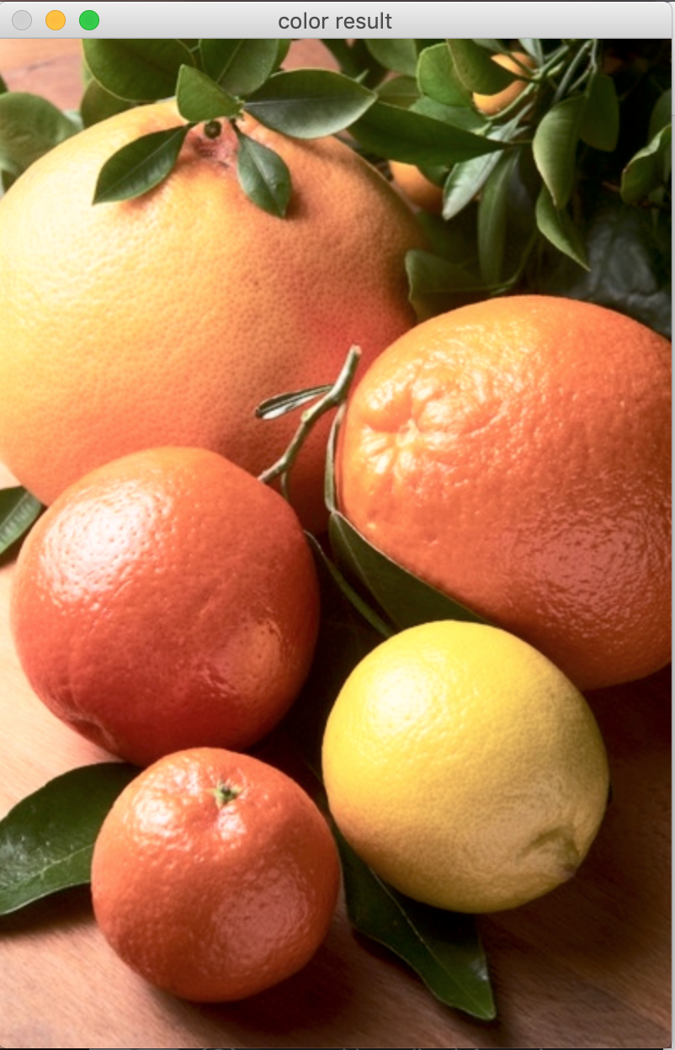

p11 image

The image which is got worst by using Linear Scaling is:

Here due to linear stretching the image is not in its highest defination, i.e now the image is a little blur from what it was in original image.

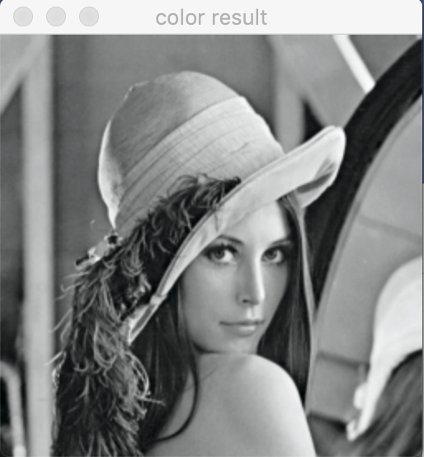

p12 image

**Second Program: Histogram Equalization**

File name: he.py

Images used in the program are:

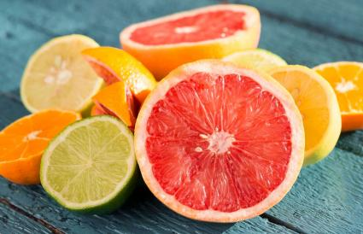

And

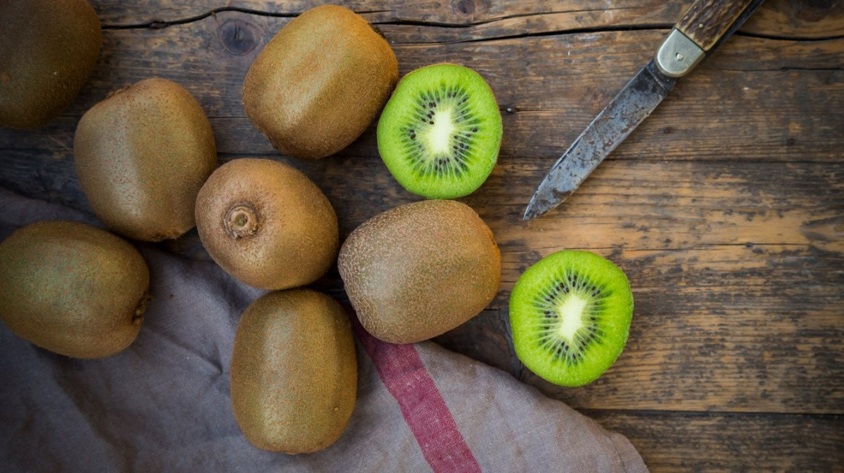

The image which is enhanced by using Histogram Equalization is:

Here the range of L was less that’s why the image below has improved.

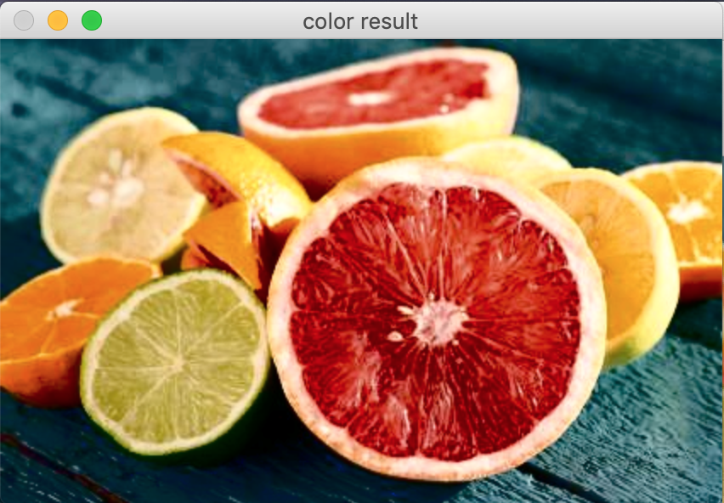

**p21 image**

The image which is got worst by using Histogram Equalization is:

In some cases, the program actually makes the image worse than the original. For example, if user choose to sample a very bright area from the original image, the output image will be very dark. On the other hand, if a very dark area is sampled, then the output image will be very bright.

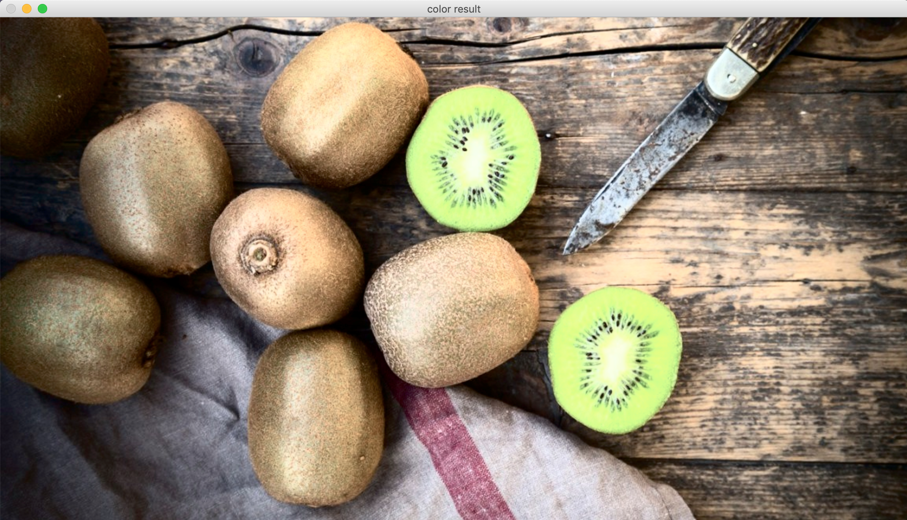

**p22 image**

**Third Program: Histogram Equalization**

File name: als.py

Images used in the program are:

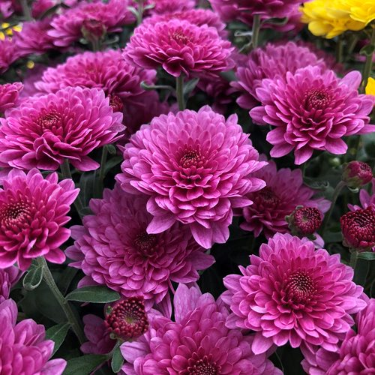

And

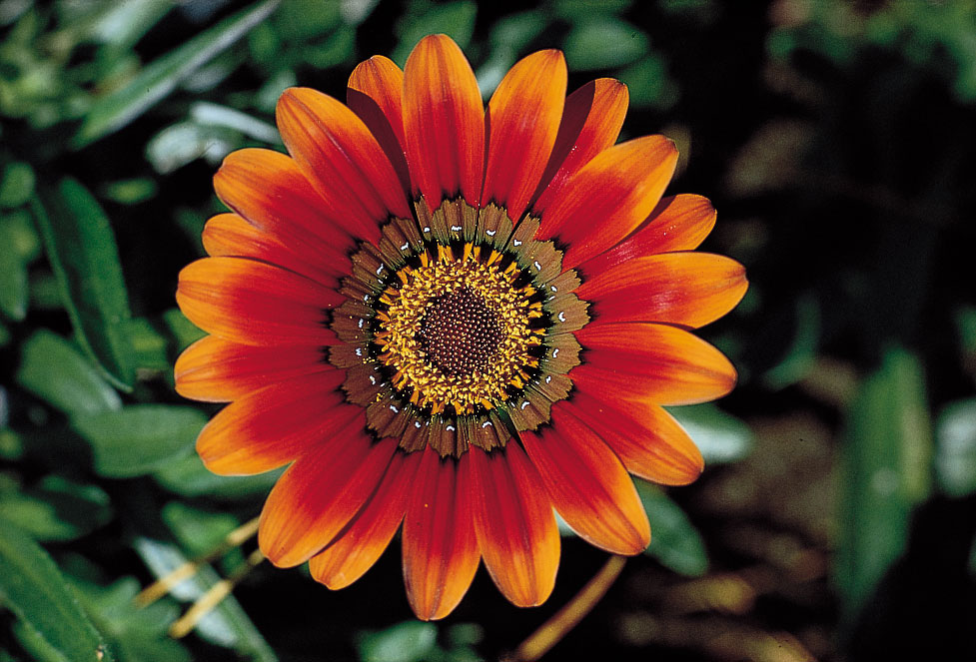

The image which is got better by using Adaptive Linear Scaling is:

Here the image is better for a small value of w and becomes worse for larger w values.

The value w take here is 10

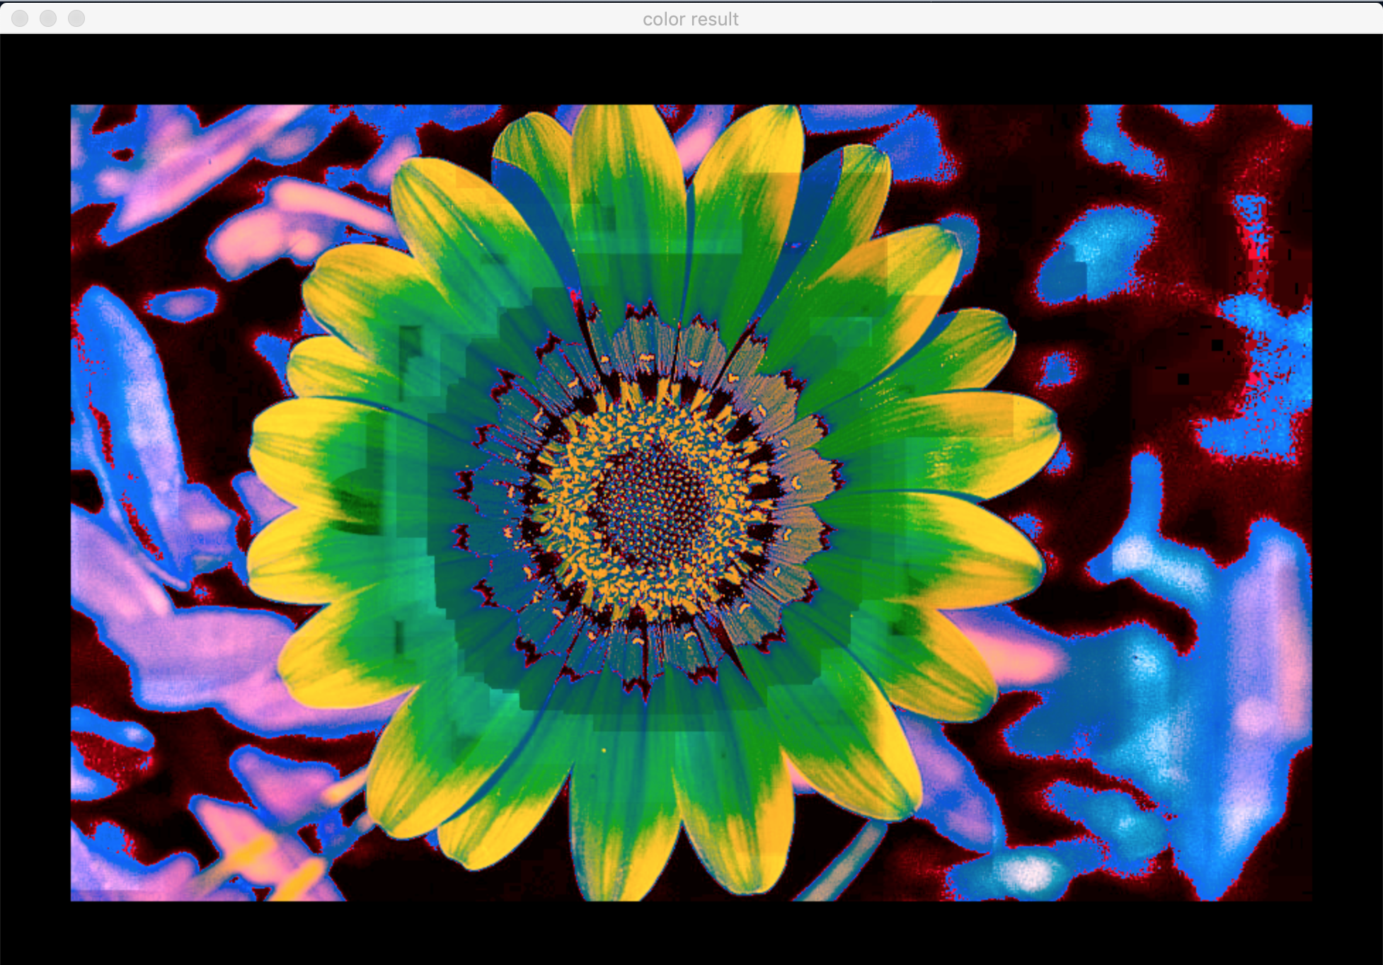

**p31 image**

The image which is got worsen by using Adaptive Linear Scaling is:

Here the image becomes worse for larger w values.

The value w take here is 50

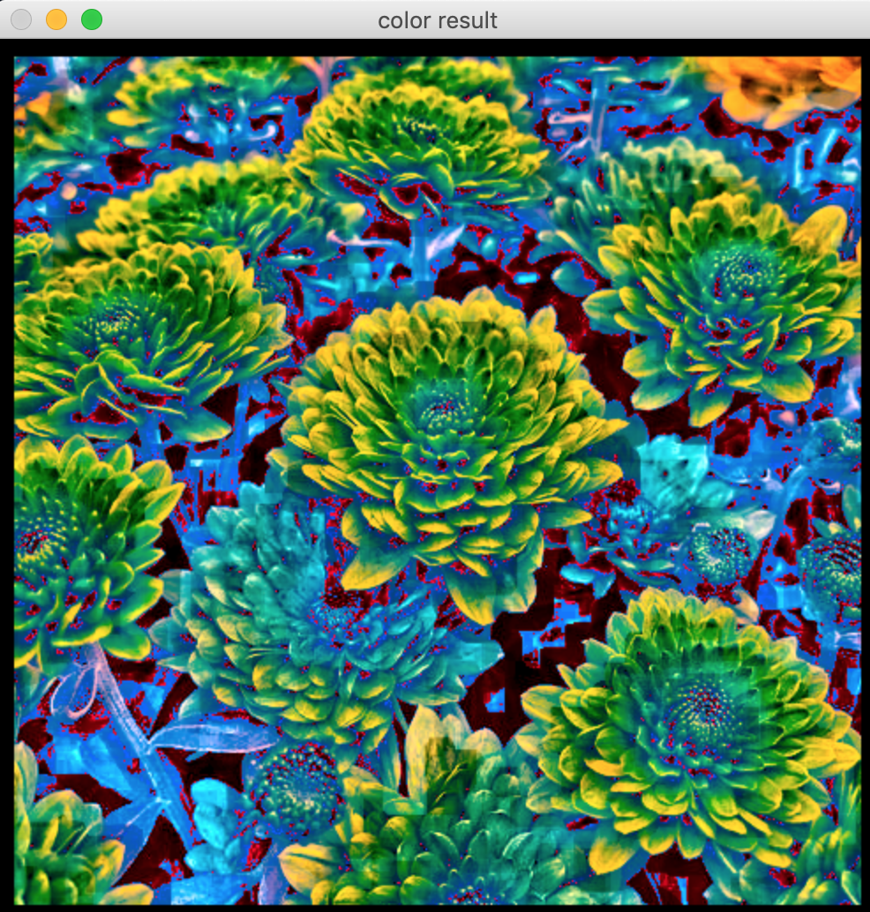

**p32 image**

**Fourth Program: Histogram Equalization**

File name: ahe.py

Images used in the program are:

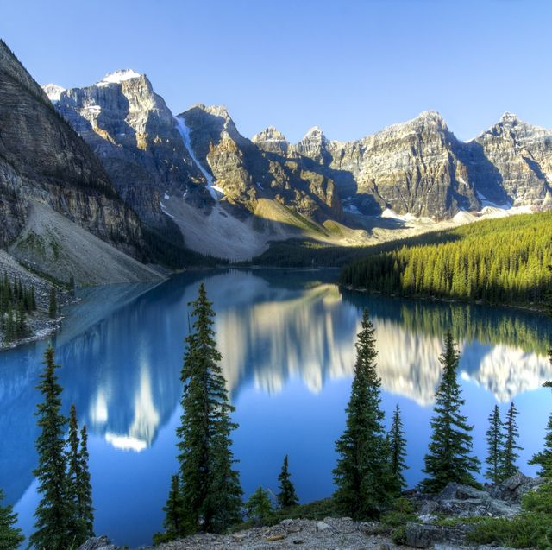

And

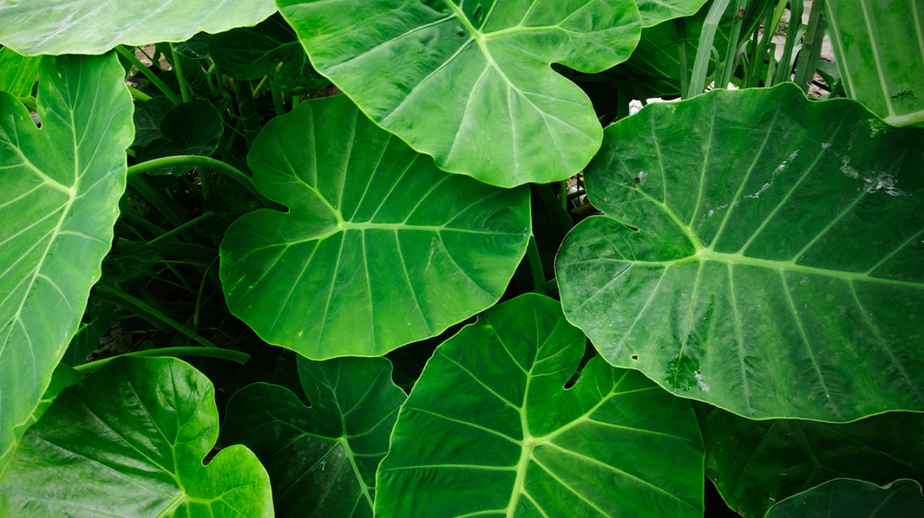

The image which is enhanced by using Adaptive Histogram Equalization is:

Here the value of w was more, ie I took the value of w = 100 and image came out to be more clear than the image with w < 100

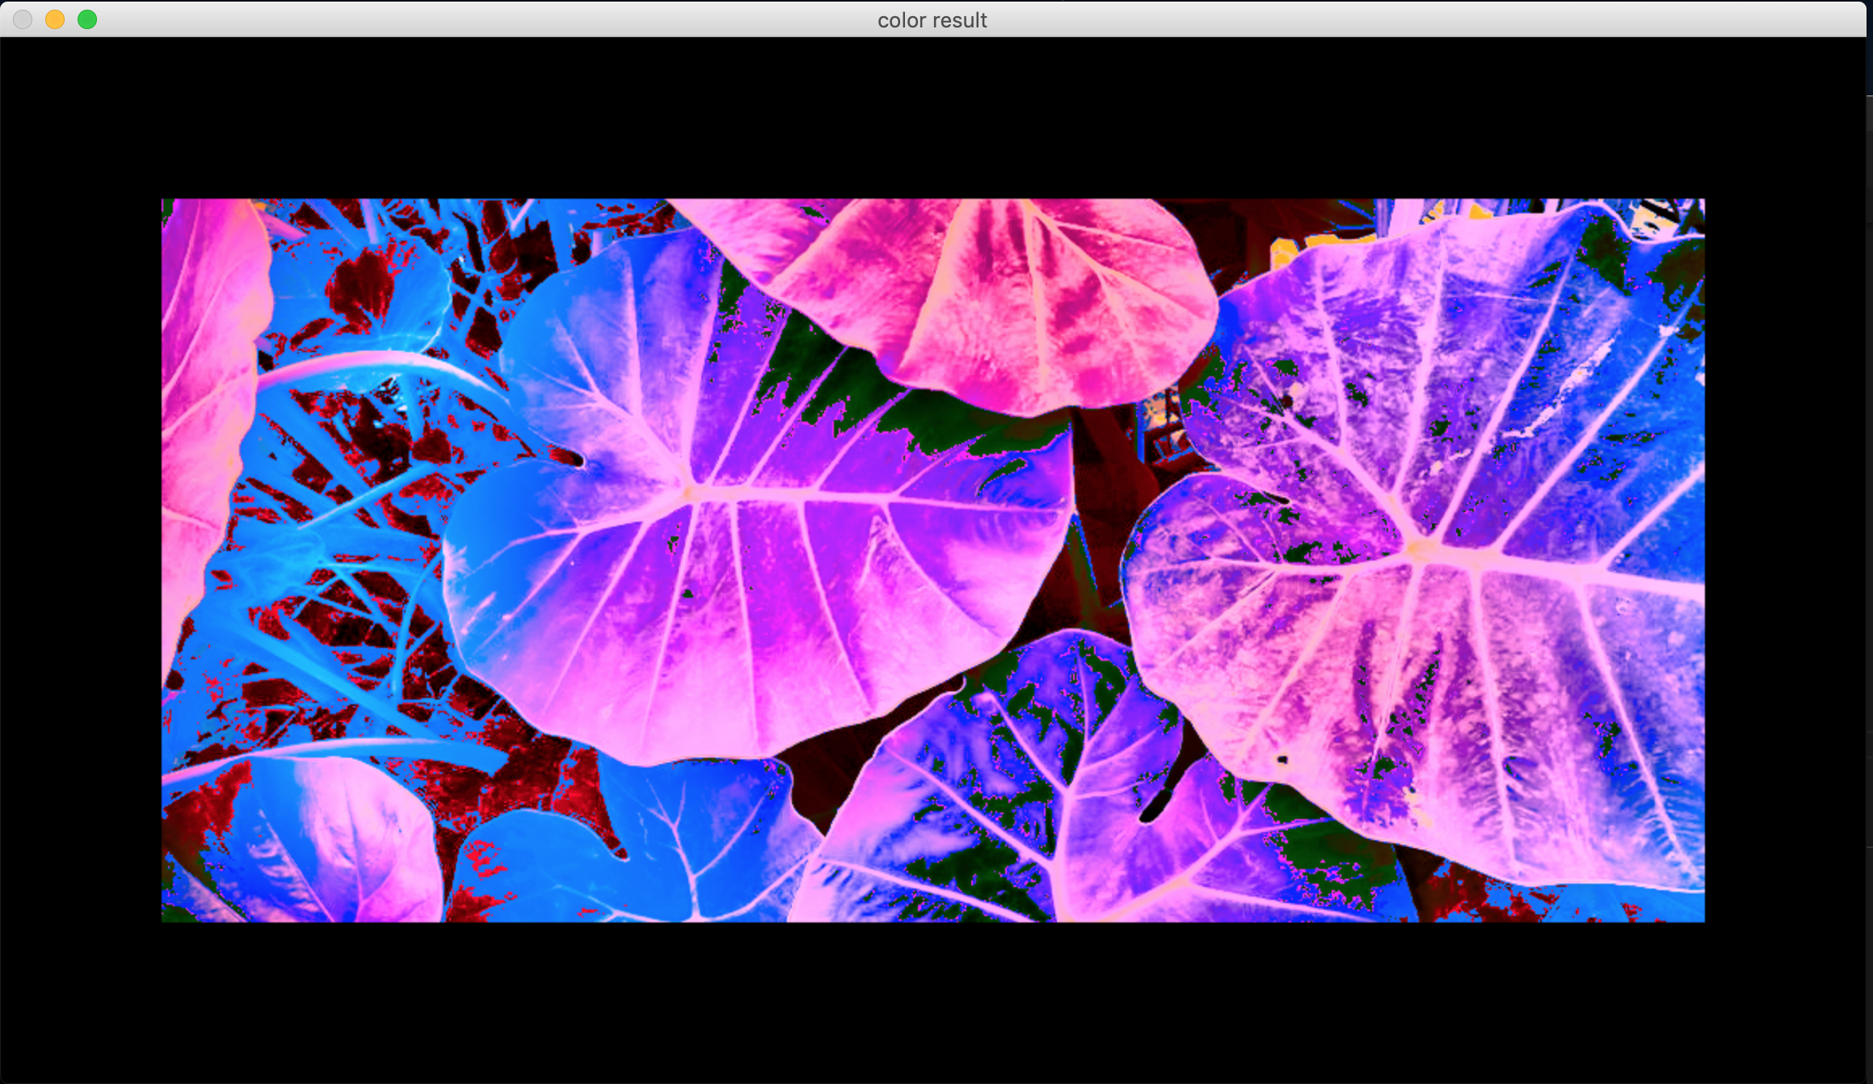

**p41 image**

The image which is worsen by using Adaptive Histogram Equalization is:

Here we took the value of w =10 and we can clearly see that the image is not clear

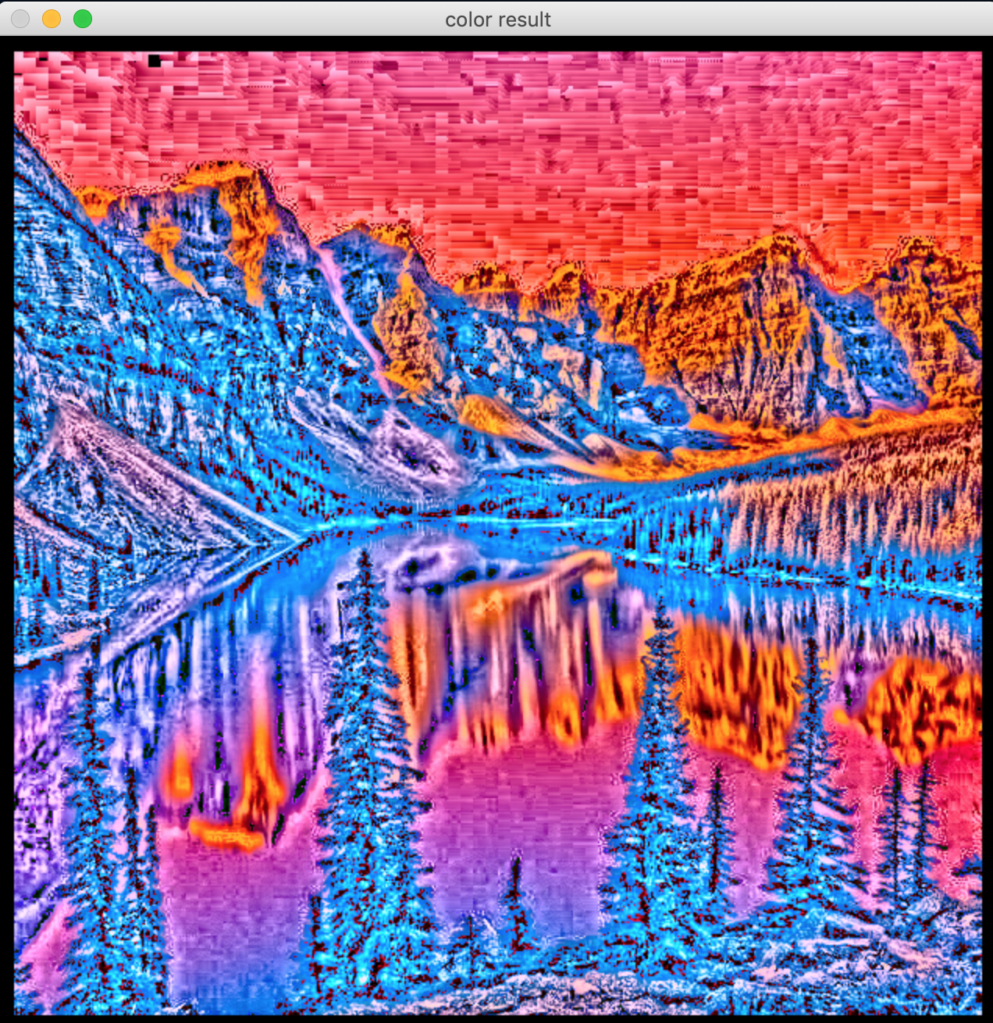

**p42 image**